EX:NO:11 | CONFERENCE MANAGEMENT SYSTEM

AIM:
To draw the diagrams [sequence] for Conference management system
SOFTWARE USED:
Umbrello
SEQUENCE DIAGRAM:

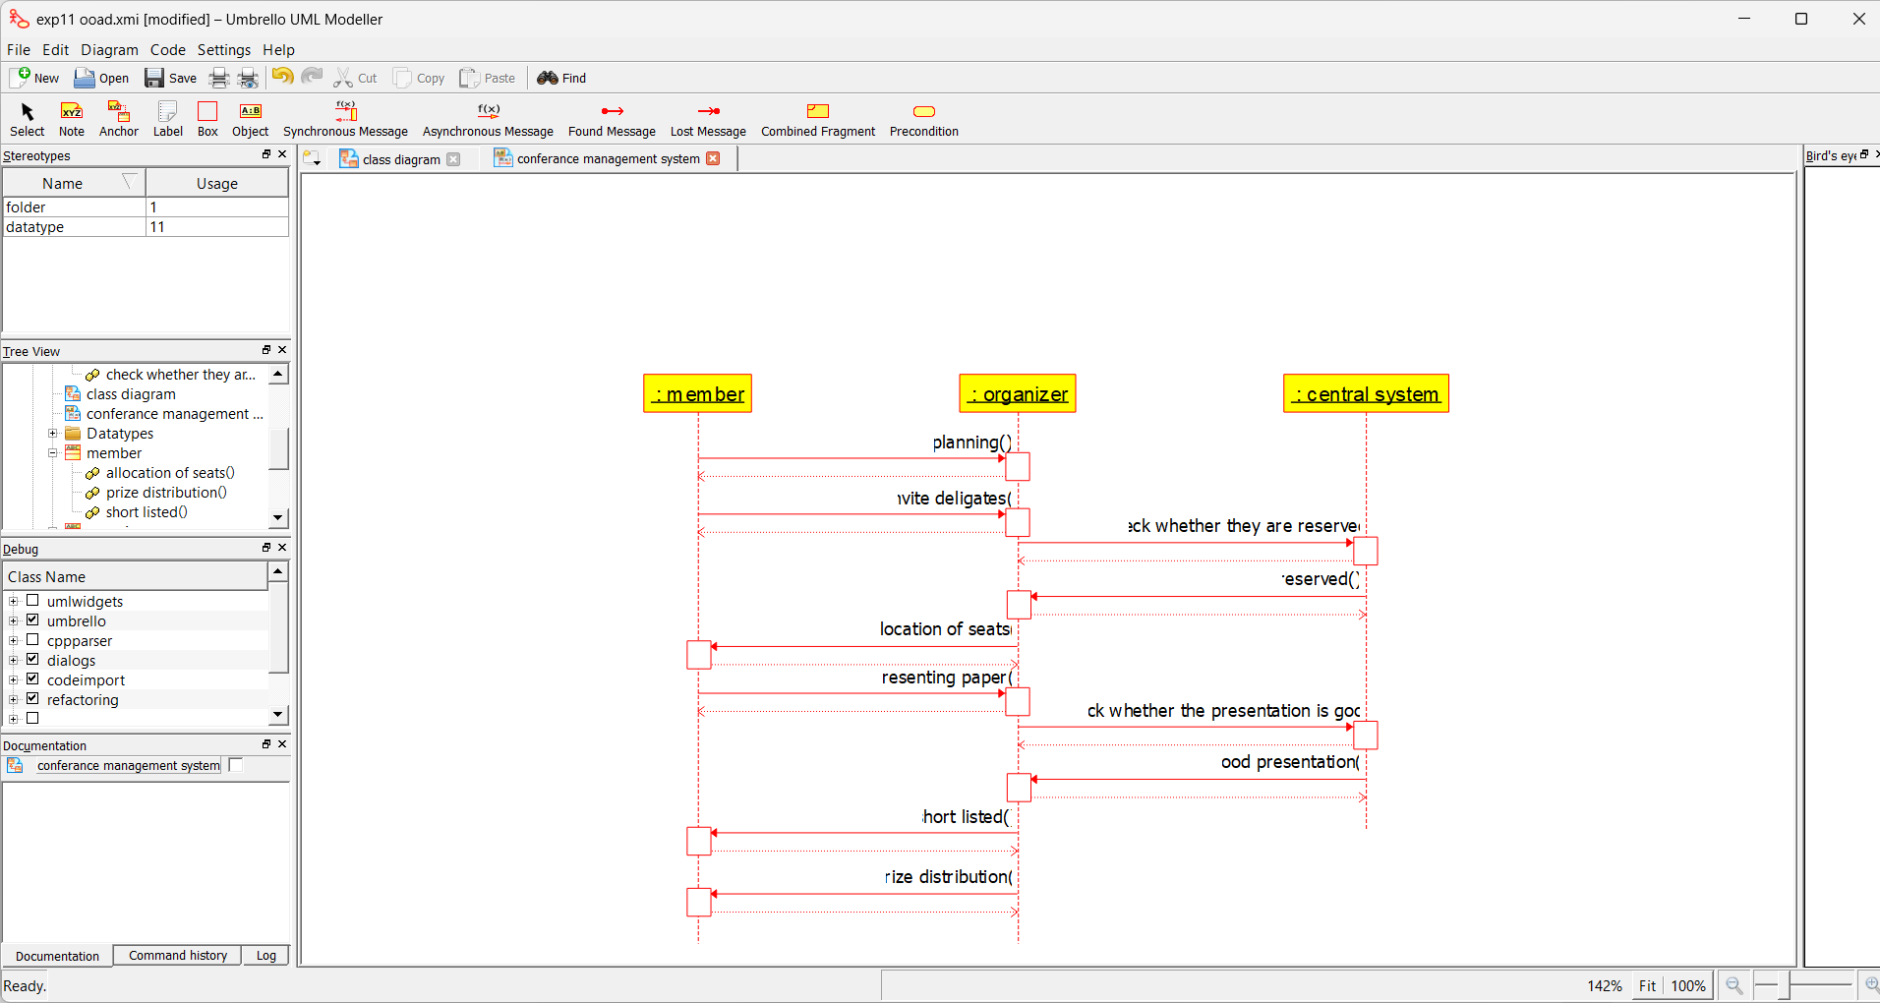
RESULT:
Thus draw the diagrams [sequence ] for Conference management system has been designed, executed and output is verified.

EX:NO:12 | FOREIGN TRADING SYSTEM

AIM:
To draw the diagrams [sequence] for foreign trading system
SOFTWARE USED:
Umbrello
SEQUENCE DIAGRAM:

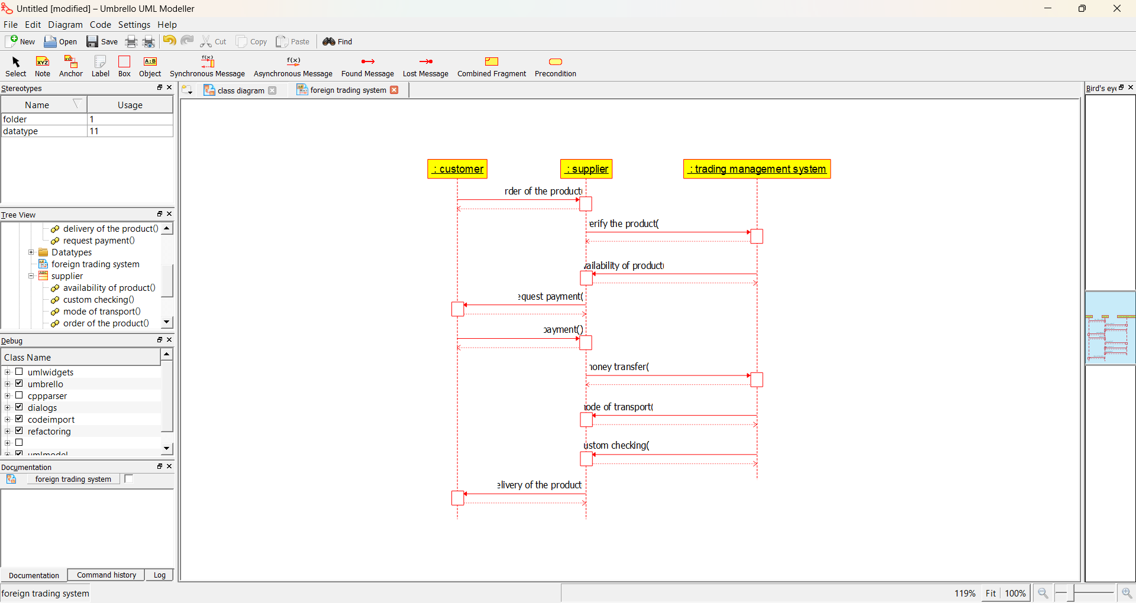
RESULT:
Thus the diagrams [sequence] for foreign trading system has been designed, executed and output is verified.

Ex.no 13 | BPO MANAGEMENT SYSTEM

AIM:
To draw the diagrams [sequence] for the BPO Management System .
SOFTWARE USED:
Umbrello
SEQUENCE DIAGRAM:

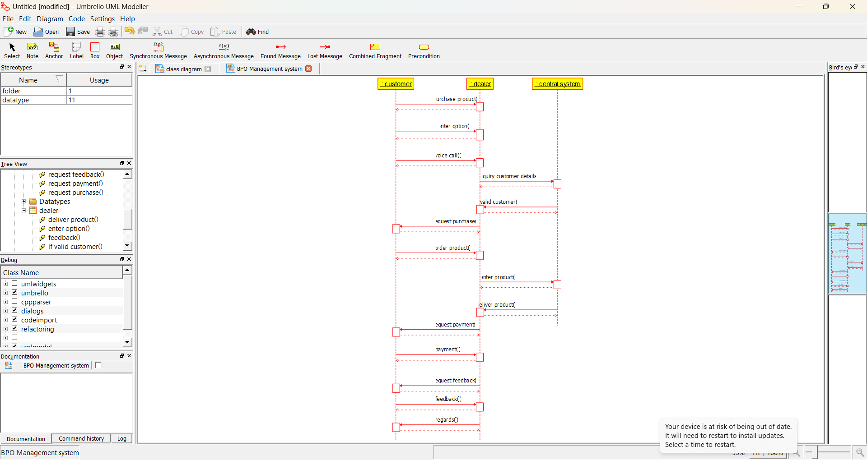
RESULT:
The diagrams [sequence] for the BPO Management system has been designed, executed and output is verified.

EX:NO:14 | E-COMMERCE REGISTRATION SYSTEM

AIM:
To draw the diagrams [sequence] for the E-Commerce Registration System.
SOFTWARE USED:
Umbrello
SEQUENCE DIAGRAM:

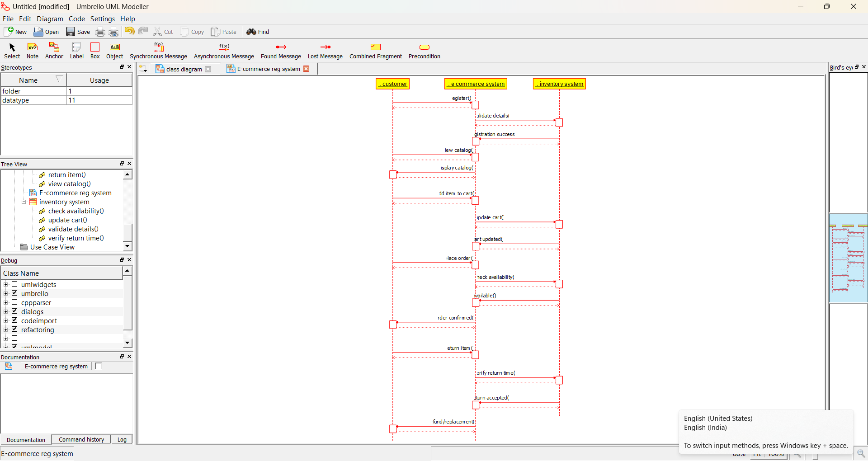
RESULT:
Thus the diagrams [sequence] for the E-Commerce Registration System has been designed, executed and output is verified.

EX:NO:15 | BLOOD BANK REGISTRATION SYSTEM

AIM:
To draw the diagrams [use case, activity, sequence, collaboration, class, statechart, component, deployment, package] for the Blood Bank Registration System.
SOFTWARE USED:
Umbrello
SEQUENCE DIAGRAM:

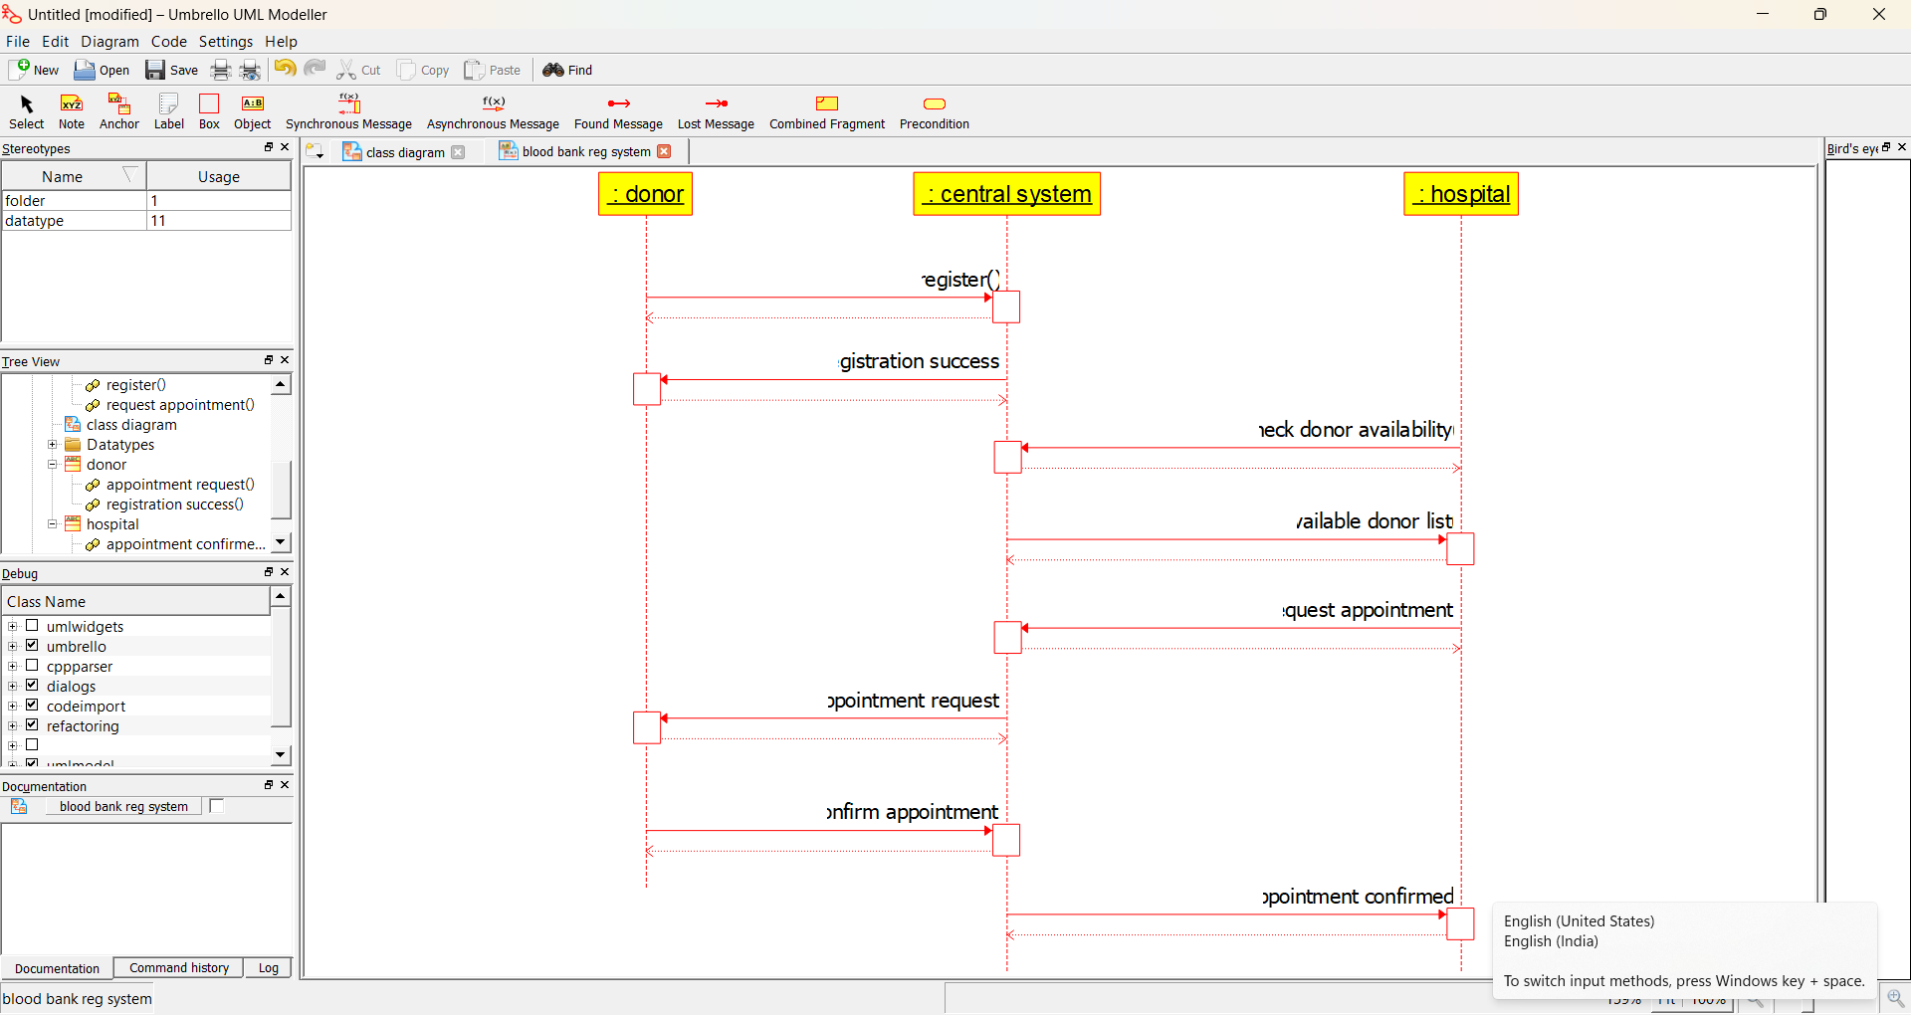
RESULT:
Thus the diagrams [sequence] for the Blood Bank Registration System has been designed, executed and output is verified.

